**FEATURE SELECTION**

**CSE 303: Machine Learning**

Submitted by

Name: Ridhi Guntur

Roll No: AP22110011467

Section: CSE M

Lab Date: 08/10/2024

Submission Date: 20/10/2024

**Department Computer Science and Engineering**

**School of Engineering and Sciences**

**SRM University–AP**

**Amaravati, Andhra Pradesh – 522 240, India**

1. **Algorithm Description**

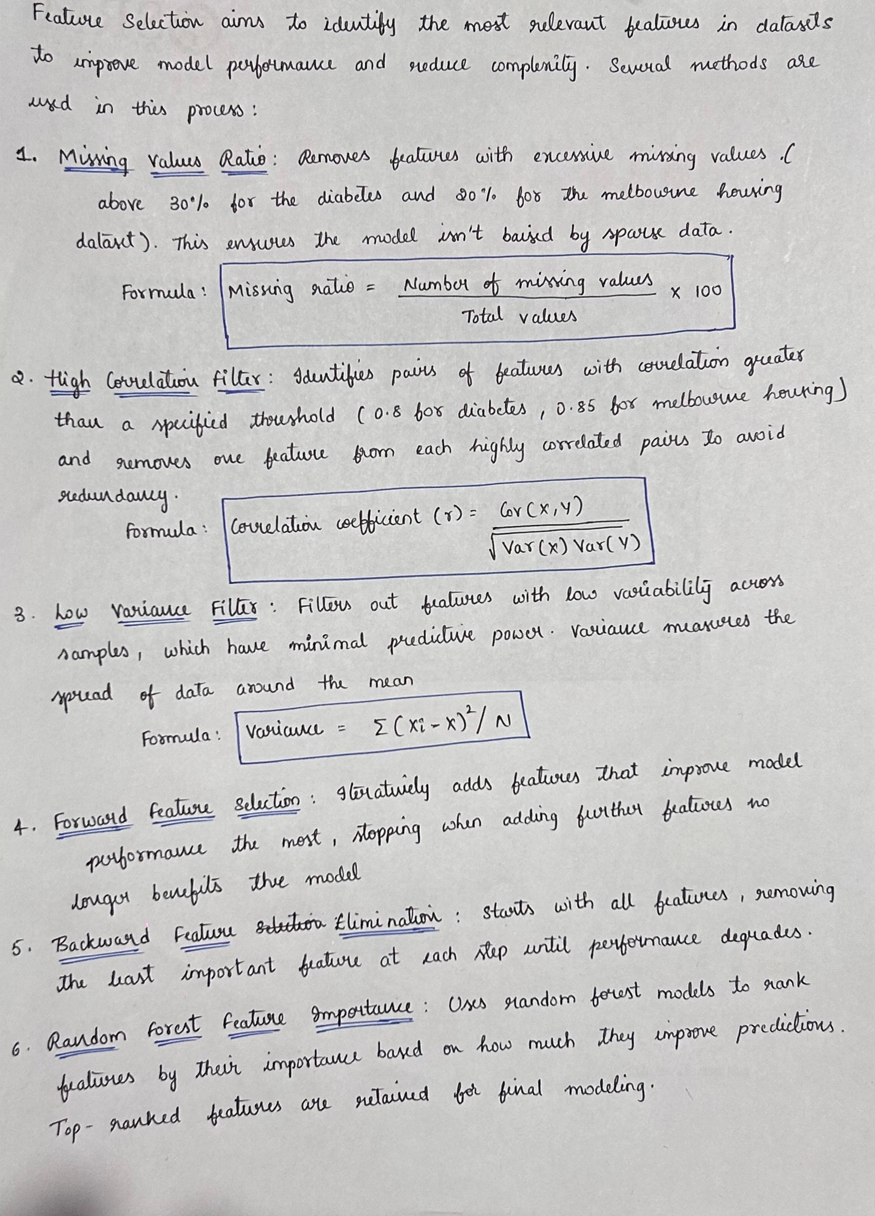

1. **Solutions**

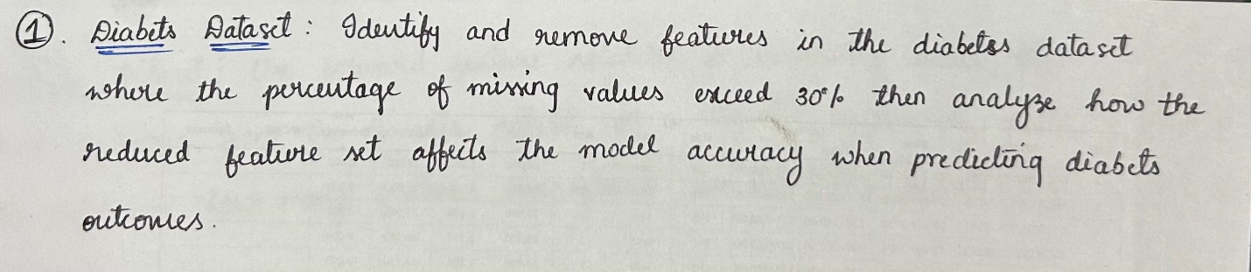

|  |
| --- |
| import pandas as pd  from sklearn.model_selection import train_test_split  from sklearn.ensemble import RandomForestClassifier  from sklearn.metrics import accuracy_score  diabetes_data = pd.read_csv((r"C:\Users\guntu\Downloads\diabetes.csv"))  # Step 1: Count the number of zero values in relevant columns (Glucose, BloodPressure, etc.)  invalid_columns = ['Glucose', 'BloodPressure', 'SkinThickness', 'Insulin', 'BMI']  zero_counts = (diabetes_data[invalid_columns] == 0).sum()  # Step 2: Calculate the percentage of zero values in these columns  missing_percentage = (zero_counts / len(diabetes_data)) * 100  # Display the number and percentage of zero values  print("Number of zero values:")  print(zero_counts)  print("\nPercentage of zero values:")  print(missing_percentage)  # Step 3: Model accuracy before removing any columns  X_full = diabetes_data.drop(columns=['Outcome'])  y_full = diabetes_data['Outcome']  X_train_full, X_test_full, y_train_full, y_test_full = train_test_split(X_full, y_full, test_size=0.2, random_state=42)  # Train the RandomForest model on full data  model_full = RandomForestClassifier(random_state=42)  model_full.fit(X_train_full, y_train_full)  y_pred_full = model_full.predict(X_test_full)  accuracy_full = accuracy_score(y_test_full, y_pred_full)  print("\nModel Accuracy before removing columns: {:.2f}%".format(accuracy_full * 100))  columns_to_remove = missing_percentage[missing_percentage > 30].index  reduced_data = diabetes_data.drop(columns=columns_to_remove)  print("\nReduced dataset columns:")  print(reduced_data.columns)  # Step 5: Model accuracy after removing columns with more than 30% missing values  X_reduced = reduced_data.drop(columns=['Outcome']) # Features after reduction  y_reduced = reduced_data['Outcome']  X_train_reduced, X_test_reduced, y_train_reduced, y_test_reduced = train_test_split(X_reduced, y_reduced, test_size=0.2, random_state=42)  model_reduced = RandomForestClassifier(random_state=42)  model_reduced.fit(X_train_reduced, y_train_reduced)  y_pred_reduced = model_reduced.predict(X_test_reduced)  accuracy_reduced = accuracy_score(y_test_reduced, y_pred_reduced)  print("\nModel Accuracy after removing columns: {:.2f}%".format(accuracy_reduced * 100)) |

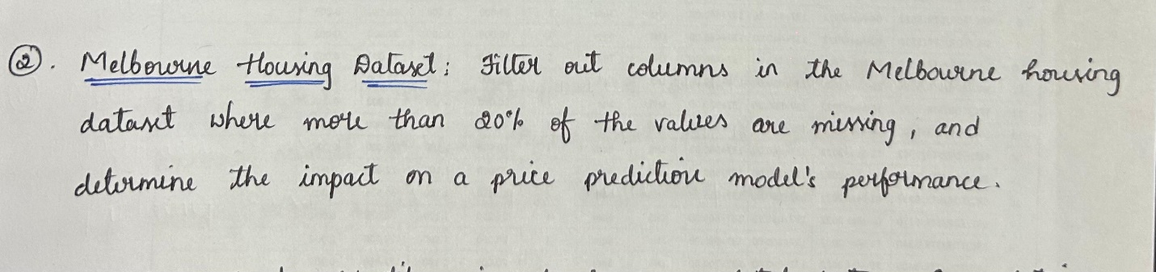

|  |
| --- |
| import pandas as pd  from sklearn.model_selection import train_test_split  from sklearn.linear_model import LinearRegression  from sklearn.metrics import mean_absolute_error, mean_squared_error, r2_score  from sklearn.impute import SimpleImputer  from sklearn.preprocessing import StandardScaler  melbourne_data = pd.read_csv(r"C:\Users\guntu\Downloads\melbourne_housing_raw.csv")  missing_counts = melbourne_data.isnull().sum() # Count of missing values  missing_ratios = melbourne_data.isnull().mean() * 100 # Percentage of missing values  print("Missing Values:")  for col in melbourne_data.columns:  print(f"{col}: {missing_counts[col]} ")  print("\nPercentage of Missing Values:")  for col in melbourne_data.columns:  print(f"{col}: {missing_ratios[col]:.2f}%")  columns_to_drop = missing_ratios[missing_ratios > 20].index.tolist()  print("\nColumns to be removed (more than 20% missing values):")  for col in columns_to_drop:  print(col)  if 'Price' in columns_to_drop:  columns_to_drop.remove('Price')  filtered_data = melbourne_data.drop(columns=columns_to_drop).dropna(subset=['Price'])  # Define features (X) and target (y)  X = filtered_data.drop(columns=['Price'])  y = filtered_data['Price']  X_encoded = pd.get_dummies(X, drop_first=True)  imputer = SimpleImputer(strategy='median')  X_imputed = imputer.fit_transform(X_encoded)  scaler = StandardScaler()  X_scaled = scaler.fit_transform(X_imputed)  X_train, X_test, y_train, y_test = train_test_split(X_scaled, y, test_size=0.2, random_state=42)  model = LinearRegression()  model.fit(X_train, y_train)  y_pred = model.predict(X_test)  mae = mean_absolute_error(y_test, y_pred)  mse = mean_squared_error(y_test, y_pred)  r2 = r2_score(y_test, y_pred)  print(f'\nMean Absolute Error (MAE): {mae:.2f}')  print(f'Mean Squared Error (MSE): {mse:.2f}')  print(f'R² Score: {r2:.2f}') |

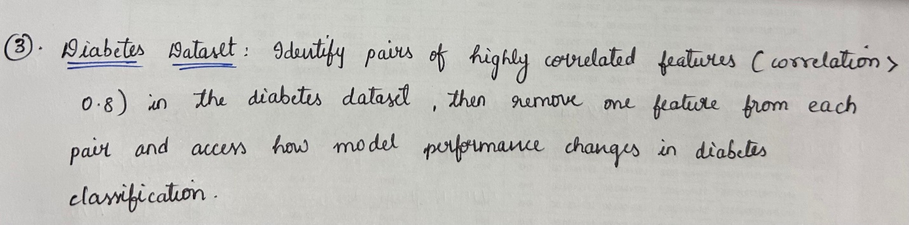

|  |
| --- |
| import pandas as pd  import numpy as np  from sklearn.model_selection import train_test_split  from sklearn.linear_model import LogisticRegression  from sklearn.metrics import accuracy_score  data = pd.read_csv((r"C:\Users\guntu\Downloads\diabetes.csv"))  # Compute the correlation matrix  print("Computing the correlation matrix \n")  corr_matrix = data.corr()  print(corr_matrix, "\n")  corr_pairs = []  for i in range(len(corr_matrix.columns)):  for j in range(i + 1, len(corr_matrix.columns)):  corr_value = corr_matrix.iloc[i, j]  if abs(corr_value) > 0.8:  corr_pairs.append((corr_matrix.columns[i], corr_matrix.columns[j], corr_value))  if corr_pairs:  print("Highly Correlated Pairs:")  for pair in corr_pairs:  print(f"{pair[0]} and {pair[1]}: Correlation = {pair[2]:.2f}")  else:  print("No pairs with correlation > 0.8 found.\n")  features_to_remove = set(pair[1] for pair in corr_pairs) # Keep only one feature from each pair  data_reduced = data.drop(columns=features_to_remove)  print(f"Features removed: {features_to_remove}\n")  # Split the data into train and test sets  X = data.drop(columns='Outcome')  X_reduced = data_reduced.drop(columns='Outcome')  y = data['Outcome']  X_train, X_test, y_train, y_test = train_test_split(X, y, test_size=0.3, random_state=42)  X_train_reduced, X_test_reduced, _, _ = train_test_split(X_reduced, y, test_size=0.3, random_state=42)  # Train models on both versions of the dataset  model = LogisticRegression(max_iter=500)  model_reduced = LogisticRegression(max_iter=500)  model.fit(X_train, y_train)  model_reduced.fit(X_train_reduced, y_train)  # Evaluate model performance  y_pred = model.predict(X_test)  y_pred_reduced = model_reduced.predict(X_test_reduced)  accuracy = accuracy_score(y_test, y_pred)  print(f"Accuracy with all features: {accuracy:.4f}")  accuracy_reduced = accuracy_score(y_test, y_pred_reduced)  print(f"Accuracy with reduced features: {accuracy_reduced:.4f}\n") |

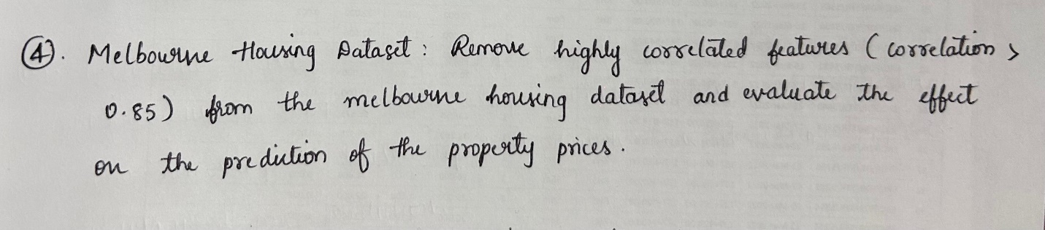

|  |
| --- |
| import pandas as pd  import numpy as np  from sklearn.model_selection import train_test_split  from sklearn.linear_model import LinearRegression  from sklearn.metrics import mean_squared_error, r2_score  from sklearn.preprocessing import OneHotEncoder  import seaborn as sns  import matplotlib.pyplot as plt  # Load the dataset  df = pd.read_csv(r"C:\Users\guntu\Downloads\melbourne_housing_raw.csv")  # Handle missing values by dropping rows with missing values  df_cleaned = df.dropna()  # Verify there are no missing values  print(df_cleaned.isnull().sum())  # Remove non-numeric columns before calculating the correlation matrix  df_numeric = df_cleaned.select_dtypes(include=[np.number])  # Compute the correlation matrix for numeric columns only  correlation_matrix = df_numeric.corr()  print(correlation_matrix)  # Identify and remove highly correlated features (correlation > 0.85)  threshold = 0.85  high_corr_features = np.where(correlation_matrix > threshold)  high_corr_pairs = [(correlation_matrix.index[x], correlation_matrix.columns[y]) for x, y in zip(*high_corr_features) if x != y and x < y]  print("Highly correlated features (correlation > 0.85): \n " , high_corr_pairs)  # Remove one feature from each highly correlated pair  features_to_remove = set([pair[1] for pair in high_corr_pairs])  df_reduced = df_cleaned.drop(columns=features_to_remove)  # Convert categorical variables into numerical values using OneHotEncoder  df_reduced = pd.get_dummies(df_reduced, drop_first=True)  X = df_reduced.drop(columns=['Price'])  y = df_reduced['Price']  X_train, X_test, y_train, y_test = train_test_split(X, y, test_size=0.2, random_state=42)  # Train a linear regression model  model = LinearRegression()  model.fit(X_train, y_train)  y_pred = model.predict(X_test)  mse = mean_squared_error(y_test, y_pred)  print(f"Mean Squared Error: {mse}")  r2 = r2_score(y_test, y_pred)  print(f"R-squared: {r2}") |

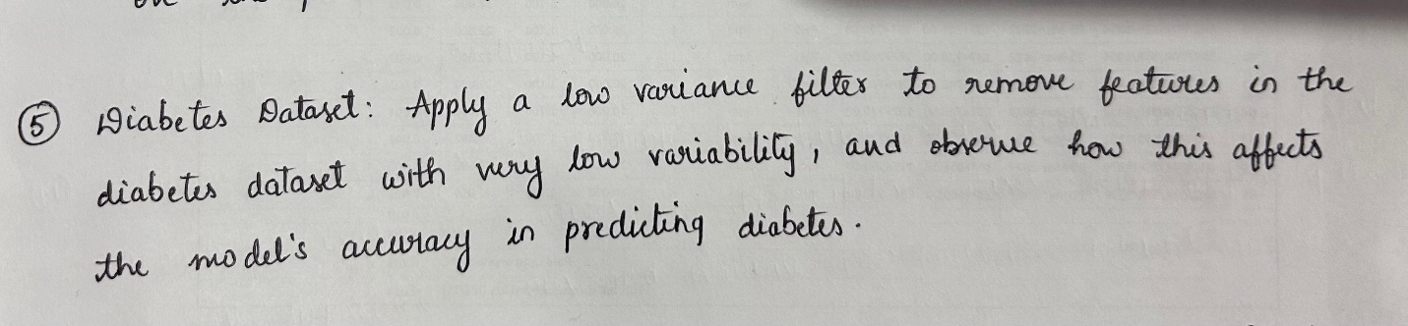

|  |
| --- |
| import pandas as pd  import numpy as np  from sklearn.model_selection import train_test_split  from sklearn.linear_model import LogisticRegression  from sklearn.metrics import accuracy_score  from sklearn.feature_selection import VarianceThreshold  data = pd.read_csv(r"C:\Users\guntu\Downloads\diabetes.csv")  X = data.drop(columns='Outcome')  y = data['Outcome']  # Calculate the variance of each feature  variances = X.var()  print("Variance of features:\n", variances, "\n")  # Apply a low variance filter with a threshold of 1.0  selector = VarianceThreshold(threshold=1.0)  X_reduced = selector.fit_transform(X)  # Get the names of features that remain after filtering  remaining_features = X.columns[selector.get_support()]  print(f"Remaining Features after Low Variance Filter: {list(remaining_features)}")  print(f"Reduced dataset shape: {X_reduced.shape}\n")  # Split data into train and test sets  X_train, X_test, y_train, y_test = train_test_split(X, y, test_size=0.3, random_state=42)  X_train_reduced, X_test_reduced, _, _ = train_test_split(X_reduced, y, test_size=0.3, random_state=42)  # Train Logistic Regression models  model = LogisticRegression(max_iter=500)  model_reduced = LogisticRegression(max_iter=500)  model.fit(X_train, y_train)  model_reduced.fit(X_train_reduced, y_train)  y_pred = model.predict(X_test)  y_pred_reduced = model_reduced.predict(X_test_reduced)  accuracy = accuracy_score(y_test, y_pred)  accuracy_reduced = accuracy_score(y_test, y_pred_reduced)  print(f"Accuracy with all features: {accuracy:.4f}")  print(f"Accuracy with reduced features: {accuracy_reduced:.4f}\n") |

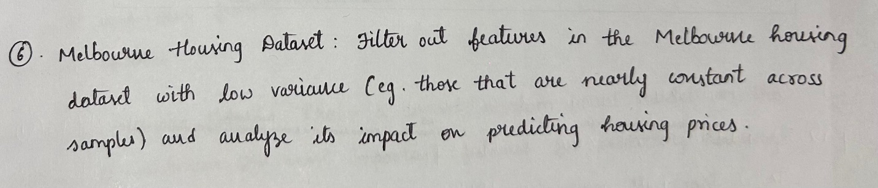

|  |
| --- |
| import pandas as pd  import numpy as np  from sklearn.feature_selection import VarianceThreshold  from sklearn.model_selection import train_test_split  from sklearn.linear_model import LinearRegression  from sklearn.metrics import mean_squared_error, r2_score  # Load the dataset from the specified file path  df = pd.read_csv(r"C:\Users\guntu\Downloads\melbourne_housing_raw.csv")  # Handle missing values by dropping rows with missing values  df_cleaned = df.dropna()  # Convert categorical variables into numerical values using OneHotEncoder or get_dummies  df_encoded = pd.get_dummies(df_cleaned, drop_first=True)  X = df_encoded.drop(columns=['Price'])  y = df_encoded['Price']  # Calculate variance of all features  feature_variances = X.var()  print("Variance of features before filtering:")  print(feature_variances)  # Apply Variance Threshold (Filter out features with variance below the threshold, e.g., 0.01)  variance_threshold = VarianceThreshold(threshold=0.01)  X_high_variance = variance_threshold.fit_transform(X)  # Get the indices of the features that were kept and removed  features_kept = X.columns[variance_threshold.get_support()]  features_removed = X.columns[~variance_threshold.get_support()]  print("\nFeatures removed after applying variance threshold:")  print(features_removed)  X_train, X_test, y_train, y_test = train_test_split(X_high_variance, y, test_size=0.2, random_state=42)  # Train a linear regression model  model = LinearRegression()  model.fit(X_train, y_train)  y_pred = model.predict(X_test)  mse = mean_squared_error(y_test, y_pred)  r2 = r2_score(y_test, y_pred)  print(f"\nMean Squared Error after removing low variance features: {mse}")  print(f"R-squared after removing low variance features: {r2}")  # Compare with model performance before filtering low variance  X_train_full, X_test_full, y_train_full, y_test_full = train_test_split(X, y, test_size=0.2, random_state=42)  model_full = LinearRegression()  model_full.fit(X_train_full, y_train_full)  y_pred_full = model_full.predict(X_test_full)  mse_full = mean_squared_error(y_test_full, y_pred_full)  r2_full = r2_score(y_test_full, y_pred_full)  print(f"\nMean Squared Error before removing low variance features: {mse_full}")  print(f"R-squared before removing low variance features: {r2_full}") |

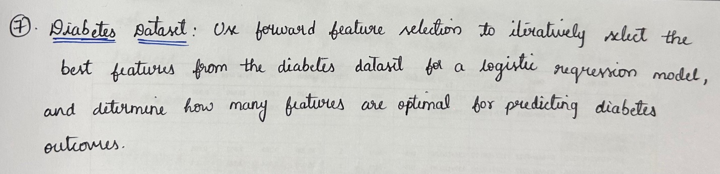

|  |
| --- |
| import pandas as pd  from sklearn.model_selection import train_test_split, cross_val_score  from sklearn.linear_model import LogisticRegression  from sklearn.metrics import accuracy_score  from sklearn.feature_selection import SequentialFeatureSelector  data = pd.read_csv(r"C:\Users\guntu\Downloads\diabetes.csv")  X = data.drop(columns='Outcome')  y = data['Outcome']  # Initialize Logistic Regression model  logreg = LogisticRegression(max_iter=500)  # Apply Forward Feature Selection  # Using SequentialFeatureSelector for forward selection  sfs = SequentialFeatureSelector(  logreg, direction='forward', scoring='accuracy', cv=5  )  sfs.fit(X, y)  # Get the selected features  selected_features = X.columns[sfs.get_support()]  print(f"Selected Features: {list(selected_features)}")  print(f"Number of selected features: {len(selected_features)}\n")  # Train model with selected features  X_selected = X[selected_features]  X_train, X_test, y_train, y_test = train_test_split(X_selected, y, test_size=0.3, random_state=42)  logreg.fit(X_train, y_train)  # Evaluate the model  y_pred = logreg.predict(X_test)  accuracy = accuracy_score(y_test, y_pred)  print(f"Accuracy with selected features: {accuracy:.4f}\n") |

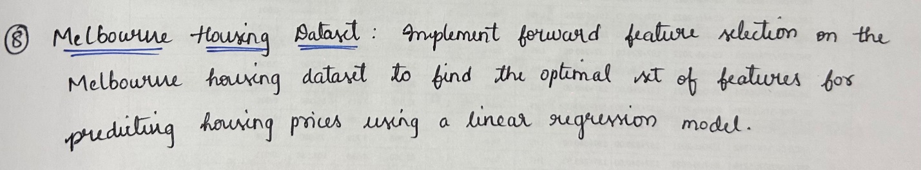

|  |
| --- |
| import pandas as pd  from sklearn.model_selection import train_test_split, cross_val_score  from sklearn.linear_model import LinearRegression  from sklearn.feature_selection import SequentialFeatureSelector  from sklearn.metrics import mean_absolute_error, make_scorer  from sklearn.impute import SimpleImputer  melbourne_data = pd.read_csv(r"C:\Users\guntu\Downloads\melbourne_housing_raw.csv")  data_clean = melbourne_data.dropna(subset=['Price'])  X = data_clean.drop(columns=['Price'])  y = data_clean['Price']  numerical_features = X.select_dtypes(include=['float64', 'int64'])  imputer = SimpleImputer(strategy='mean')  X_imputed = pd.DataFrame(imputer.fit_transform(numerical_features), columns=numerical_features.columns)  X_train, X_test, y_train, y_test = train_test_split(X_imputed, y, test_size=0.2, random_state=42)  model = LinearRegression()  mae_scorer = make_scorer(mean_absolute_error, greater_is_better=False)  selector = SequentialFeatureSelector(  model,  n_features_to_select="auto",  direction='forward',  scoring=mae_scorer,  cv=5  )  selector.fit(X_train, y_train)  selected_features = X_imputed.columns[selector.get_support()]  print("Selected Features:")  print(selected_features)  X_train_selected = selector.transform(X_train)  X_test_selected = selector.transform(X_test)  model.fit(X_train_selected, y_train)  y_pred = model.predict(X_test_selected)  mae = mean_absolute_error(y_test, y_pred)  print(f"\nMean Absolute Error (MAE) with selected features: {mae:.2f}") |

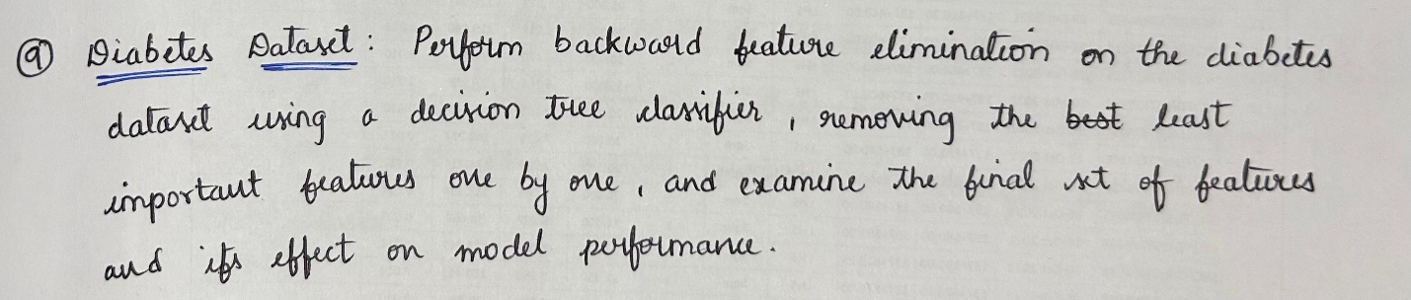

|  |
| --- |
| import pandas as pd  from sklearn.model_selection import train_test_split  from sklearn.tree import DecisionTreeClassifier  from sklearn.metrics import accuracy_score  from sklearn.feature_selection import RFE  data = pd.read_csv(r"C:\Users\guntu\Downloads\diabetes.csv")  X = data.drop(columns='Outcome')  y = data['Outcome']  # Initialize Decision Tree Classifier  model = DecisionTreeClassifier(random_state=42)  # Apply Recursive Feature Elimination (RFE) for backward feature elimination  rfe = RFE(estimator=model, n_features_to_select=1) # Keep reducing until 1 feature remains  rfe.fit(X, y)  # Print ranking of features (1 = most important)  for feature, rank in zip(X.columns, rfe.ranking_):  print(f"{feature}: Rank {rank}")  # Select the optimal set of features (those with rank 1)  selected_features = X.columns[rfe.support_]  print(f"\nFinal Selected Features: {list(selected_features)}")  print(f"Number of Selected Features: {len(selected_features)}\n")  # Train the model with selected features  X_selected = X[selected_features]  X_train, X_test, y_train, y_test = train_test_split(X_selected, y, test_size=0.3, random_state=42)  model.fit(X_train, y_train)  #Evaluate the model performance  y_pred = model.predict(X_test)  accuracy = accuracy_score(y_test, y_pred)  print(f"Accuracy with selected features: {accuracy:.4f}\n") |

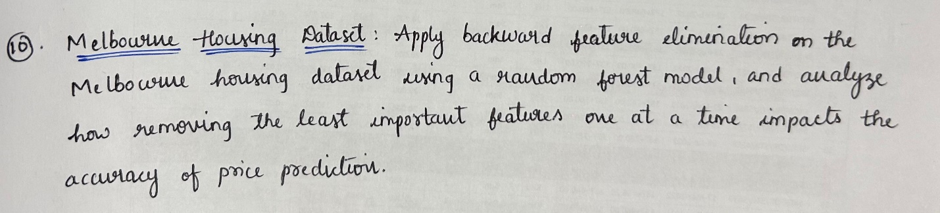

|  |
| --- |
| import pandas as pd  from sklearn.ensemble import RandomForestRegressor  from sklearn.model_selection import train_test_split  from sklearn.metrics import mean_absolute_error  from sklearn.feature_selection import RFE  from sklearn.impute import SimpleImputer  melbourne_data = pd.read_csv(r"C:\Users\guntu\Downloads\melbourne_housing_raw.csv")  melbourne_data_cleaned = melbourne_data.dropna(subset=['Price'])  X = melbourne_data_cleaned.select_dtypes(include=['float64', 'int64']).drop(columns=['Price'])  y = melbourne_data_cleaned['Price']  imputer = SimpleImputer(strategy='mean')  X_imputed = imputer.fit_transform(X)  X_train, X_test, y_train, y_test = train_test_split(X_imputed, y, test_size=0.2, random_state=42)  model = RandomForestRegressor(random_state=42)  rfe = RFE(estimator=model, n_features_to_select=1, step=1)  rfe.fit(X_train, y_train)  ranking = rfe.ranking_  feature_names = melbourne_data_cleaned.select_dtypes(include=['float64', 'int64']).drop(columns=['Price']).columns  feature_ranking = pd.DataFrame({'Feature': feature_names, 'Ranking': ranking})  feature_ranking_sorted = feature_ranking.sort_values(by='Ranking')  print("Feature Rankings:")  print(feature_ranking_sorted)  mae_list = []  features_left = list(feature_names)  for i in range(1, len(features_left)):  # Select top i features (excluding least important features)  selected_features = feature_ranking_sorted['Feature'].head(len(features_left) - i)  X_train_selected = pd.DataFrame(X_train, columns=feature_names)[selected_features]  X_test_selected = pd.DataFrame(X_test, columns=feature_names)[selected_features]  # Train and evaluate model with selected features  model.fit(X_train_selected, y_train)  y_pred = model.predict(X_test_selected)  mae = mean_absolute_error(y_test, y_pred)  mae_list.append((len(selected_features), mae))  print("\n Performance after feature elimination:")  for num_features, mae in mae_list:  print(f'Total features : {num_features}, MAE: {mae}') |

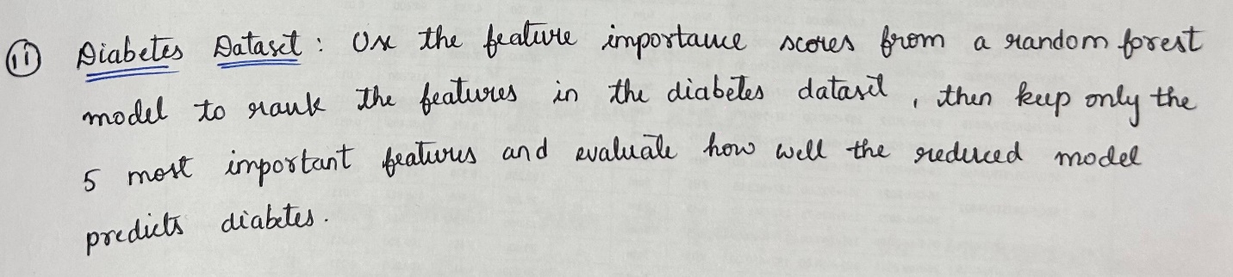

|  |
| --- |
| import pandas as pd  from sklearn.model_selection import train_test_split  from sklearn.ensemble import RandomForestClassifier  from sklearn.metrics import accuracy_score  data = pd.read_csv(r"C:\Users\guntu\Downloads\diabetes.csv")  X = data.drop(columns='Outcome')  y = data['Outcome']  # Initialize Random Forest Classifier  rf_model = RandomForestClassifier(random_state=42)  # Fit the model  rf_model.fit(X, y)  # Get feature importance scores  importance_scores = rf_model.feature_importances_  feature_importance = pd.Series(importance_scores, index=X.columns).sort_values(ascending=False)  # Print feature importance scores  print("Feature Importance Scores:")  print(feature_importance, "\n")  # Select the top 5 most important features  top_features = feature_importance.head(5).index.tolist()  print(f"Top 5 Features: {top_features}\n")  X_top = X[top_features]  X_train, X_test, y_train, y_test = train_test_split(X_top, y, test_size=0.3, random_state=42)  rf_model.fit(X_train, y_train)  # Evaluate the model performance  y_pred = rf_model.predict(X_test)  accuracy = accuracy_score(y_test, y_pred)  print(f"Accuracy with top 5 features: {accuracy:.4f}\n") |

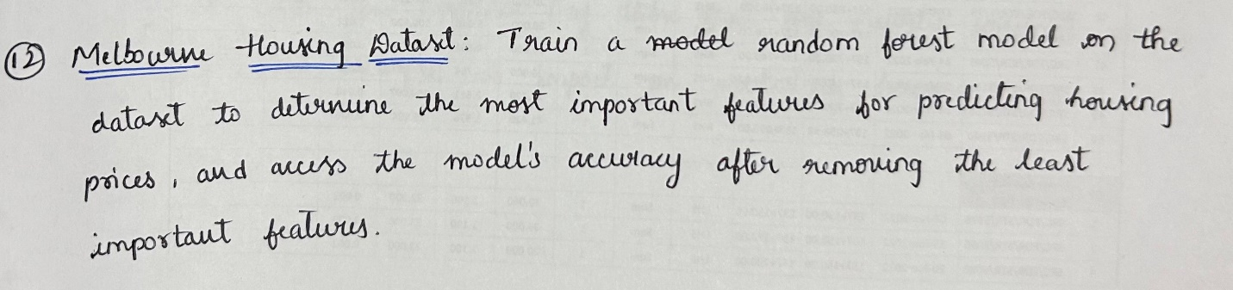

|  |
| --- |
| import pandas as pd  from sklearn.ensemble import RandomForestRegressor  from sklearn.model_selection import train_test_split  from sklearn.metrics import mean_absolute_error  from sklearn.impute import SimpleImputer  import numpy as np  melbourne_data = pd.read_csv(r"C:\Users\guntu\Downloads\melbourne_housing_raw.csv")  melbourne_data_cleaned = melbourne_data.dropna(subset=['Price'])  X = melbourne_data_cleaned.select_dtypes(include=['float64', 'int64']).drop(columns=['Price'])  y = melbourne_data_cleaned['Price']  imputer = SimpleImputer(strategy='mean')  X_imputed = imputer.fit_transform(X)  X_train, X_test, y_train, y_test = train_test_split(X_imputed, y, test_size=0.2, random_state=42)  model = RandomForestRegressor(random_state=42)  model.fit(X_train, y_train)  importances = model.feature_importances_  indices = np.argsort(importances)[::-1] # Sort by importance descending  feature_names = melbourne_data_cleaned.select_dtypes(include=['float64', 'int64']).drop(columns=['Price']).columns  print("Feature Importance Ranking:")  for idx in indices:  print(f'{feature_names[idx]}: {importances[idx]}')  y_pred = model.predict(X_test)  mae_full = mean_absolute_error(y_test, y_pred)  print(f'\nModel accuracy with all features, MAE: {mae_full}')  n_least_important = 3  least_important_features = feature_names[indices[-n_least_important:]]  selected_features_idx = indices[:-n_least_important]  X_train_reduced = X_train[:, selected_features_idx]  X_test_reduced = X_test[:, selected_features_idx]  model.fit(X_train_reduced, y_train)  y_pred_reduced = model.predict(X_test_reduced)  mae_reduced = mean_absolute_error(y_test, y_pred_reduced)  print(f'\nRemoved the {n_least_important} least important features: {list(least_important_features)}')  print(f'Model accuracy after removing these features, MAE: {mae_reduced}') |

1. **Link**